**DATASET DESCRIPTION:**

The dataset is about sales data. This dataset consists of multiple tables such as sales customers which consist of customer name, customer code, and customer type. And the second table is named sales date which includes features like date, month name, year, and date month year as one feature. The third table called sales market consists of features market code, market name, and zone. The fourth table called sales product has features like product code and product type. The fifth table is called a sales master which consists of features like address, city, pin code, revenue, sales amount, sales name, state, etc. The next table which is a sales order table consists of features like Billed_YN, Client no. And the table called sales order date consist of features like product no, product rate, quantity display, quantity order number, etc. The sales transaction consists of attributes like currency, customer code, order date, product code, the sum of cost, the sum of sales quantity, etc.

The basic measures have been created by making use of a new measure option which consists of revenue and sales quantity measure which is calculated by making use of the sum and calculate function.

***Sales Customers :***

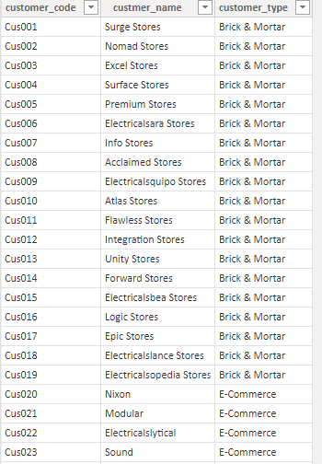

***Sales date:***

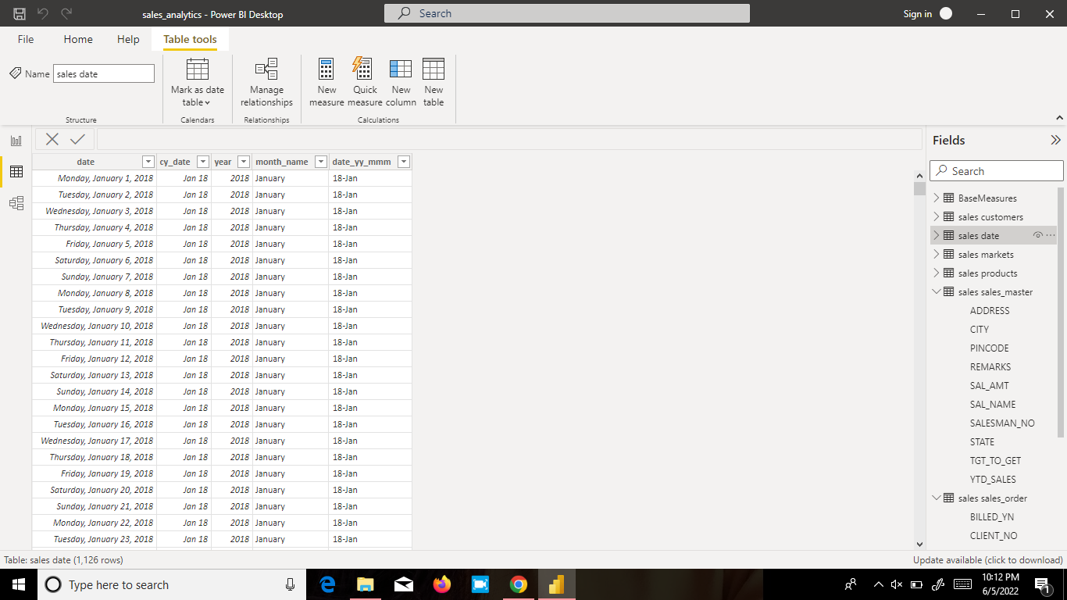

***Sales Markets:***

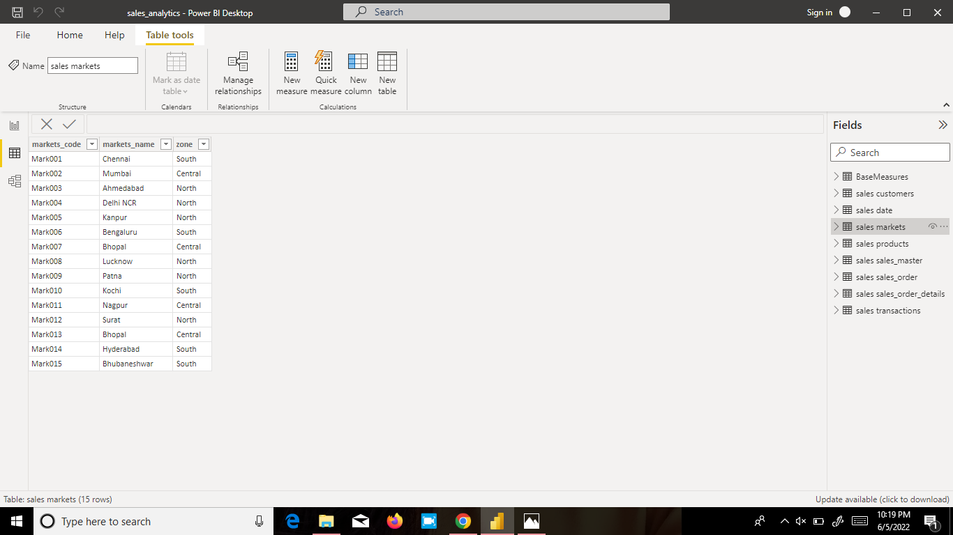

***Sales Products:***

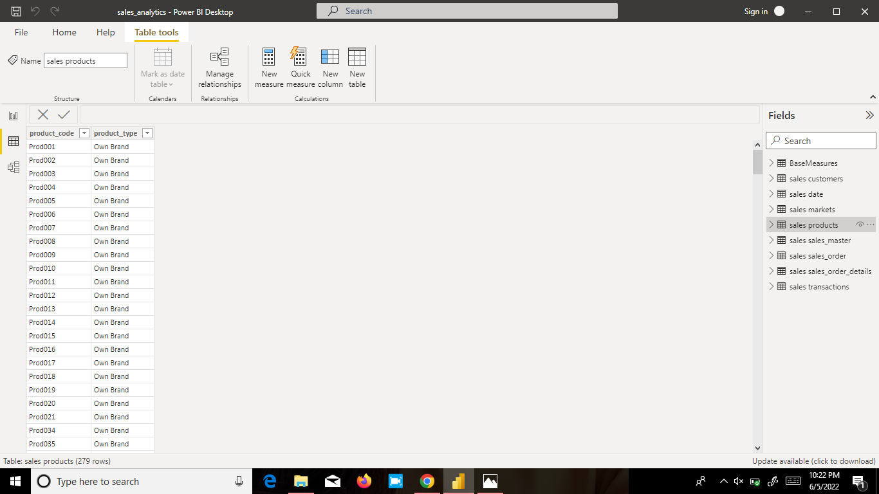

***Sales Transactions:***

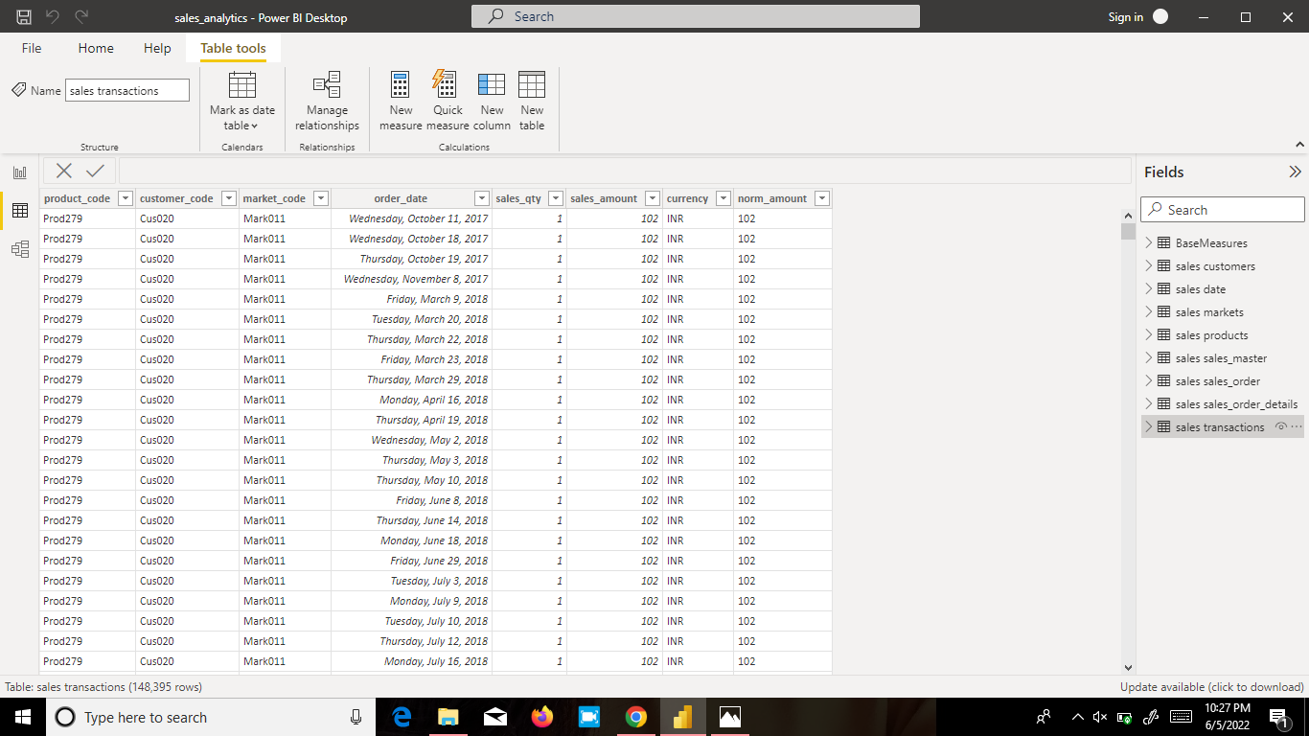

**OLAP OPERATION:**

The OLAP operation like drill down, and rollup are performed for a product and markets in the sales of India. Drill down will bring the market cities and double drill down will show up markets of India.

**VISUALISATION TECHNIQUES:**

Visualization is a process of visually presenting information/insights from a large data set so that it could be useful for future business decisions. For visualization, several charts have been used to make it present in a user-understandable format.

The visualization charts that are used for this sales analysis are

Bar Chart - This presents categorical data with rectangular bars with heights or lengths proportional to the values that they represent.

Line Chart - It is a type of chart that displays information as a series of data points connected by straight line segments.

Card - It represents a single number or a metric value.

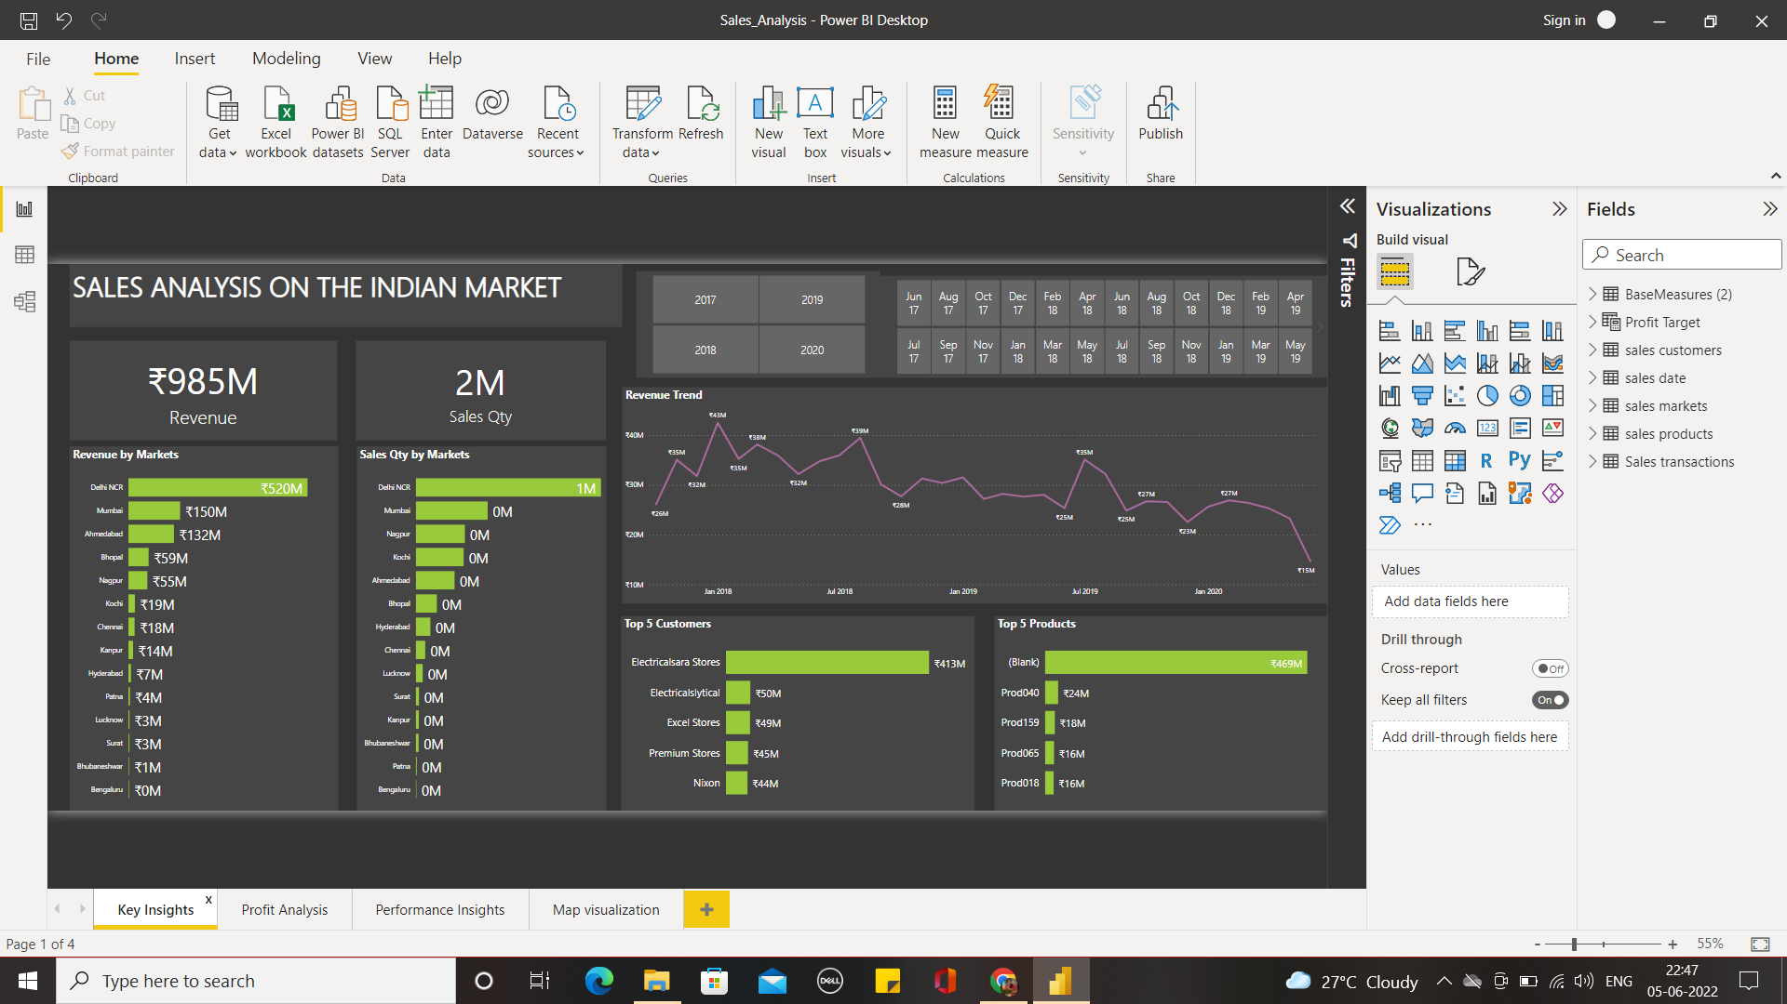

The above dashboard is about the Key Insights on the Indian Sales Market including the revenue collected from each market, sales of each market, the revenue trends over the years, and top customers, and top products. These insights can be exclusively viewed for each market. The revenue can be viewed respectively with each month and the year using a slicer. The Revenue for each year that is selected by making use of the slicer has been depicted by trend lines.

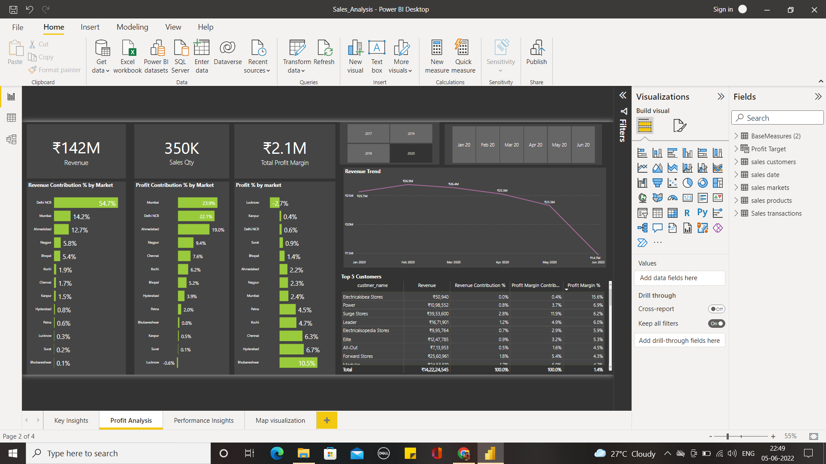

The above dashboard is about the Profit Insights on the Indian Sales Market including the revenue collected from each market, sales of each market, the revenue trends over the years, top customers, and top products. These insights can be exclusively viewed for each market. The revenue can be viewed respectively with each month and the year using a slicer. The Revenue for each year that is selected by making use of the slicer has been depicted by trend lines.

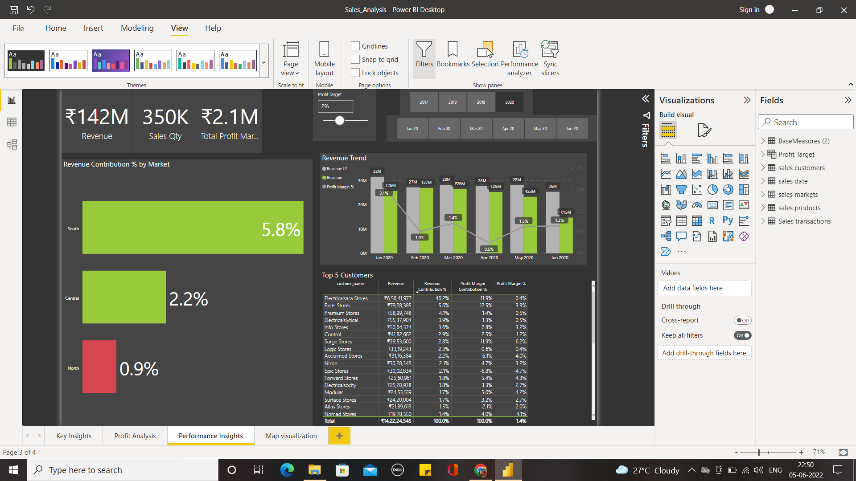

The above dashboard is about the Performance Insights on the Indian Sales Market including the revenue collected from each market, sales of each market, the revenue trends over the years, top customers, and top products. These insights can be exclusively viewed for each market. The revenue can be viewed respectively for each month and the year using a slicer. The Revenue for each year that is selected by making use of the slicer has been depicted by trend lines. Based on the profit target which can be adjusted by making use of the slicer the underperforming markets and customers can be found. (Red bars in the bar chart indicate the markets below the profit target).

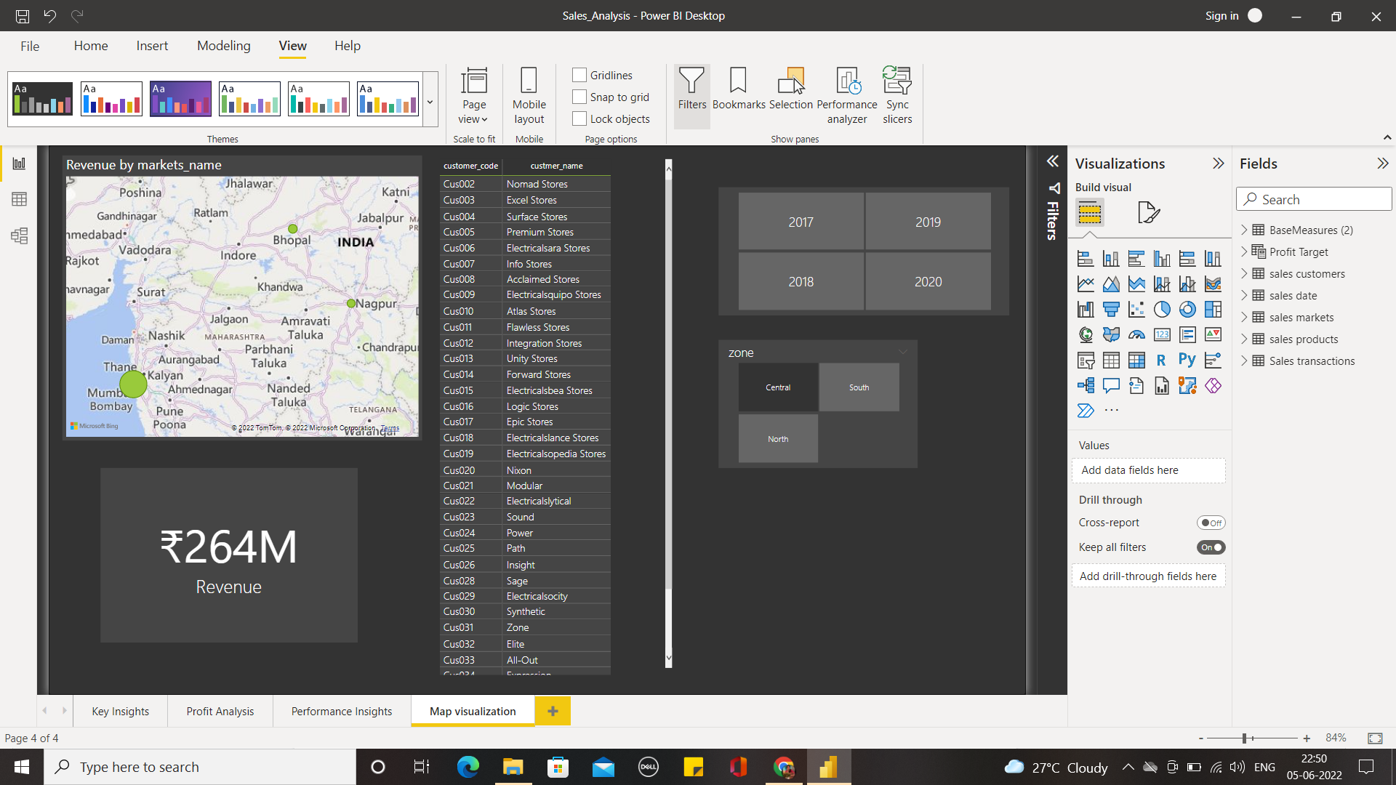

By using the Map visualization technique the market having higher revenue is indicated by a larger bubble. Using the slicer the market which contributes the highest revenue for each year is visualised using the slicer.

**INFERENCE:**

Thus by making use of different visualization charts the proper insights for the large set of sales data have been analyzed.

OLAP operations have been performed where multiple dimensions have been placed in a multidimensional space.

Slicer which makes the results be viewed for a particular dimension.

**CONCLUSION:**

Thus by making use of OLAP operations, slicer, and different visualization techniques the sales data has been analyzed by performing key insights on revenue data were given how the revenue for the different markets in India has been for a particular year. And Profit and Performance Insights have been performed to bring out insights into the profit and revenue contribution of different markets in India. The underperforming markets and the specific customers in revenue contribution are also identified.